**IFT 466 Advanced Computer Networks**

**Lab 24  
STP: Final Challenge**

**After you complete each step, put a ‘√’ or ‘x’ in the completed box**

**Or**

**Answer the open questions**

**Objectives**

* Perform basic configuration tasks on a switch
* Configure VLAN Trunking Protocol (VTP) on all switches
* Observe and explain the default behavior of Spanning Tree Protocol (STP, 802.1D)

1. Setup the following topology in packet tracker. I just used the standard Cisco Catalyst 2960 switch.

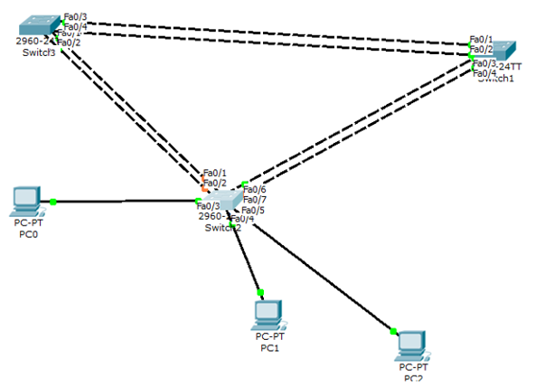

 ✓

1. Configure the following on each of the three switches.

* Configure the switch hostname.
* Disable DNS lookup.
* Configure an EXEC mode password of class.
* Configure a password of cisco for console connections.



✓

1. 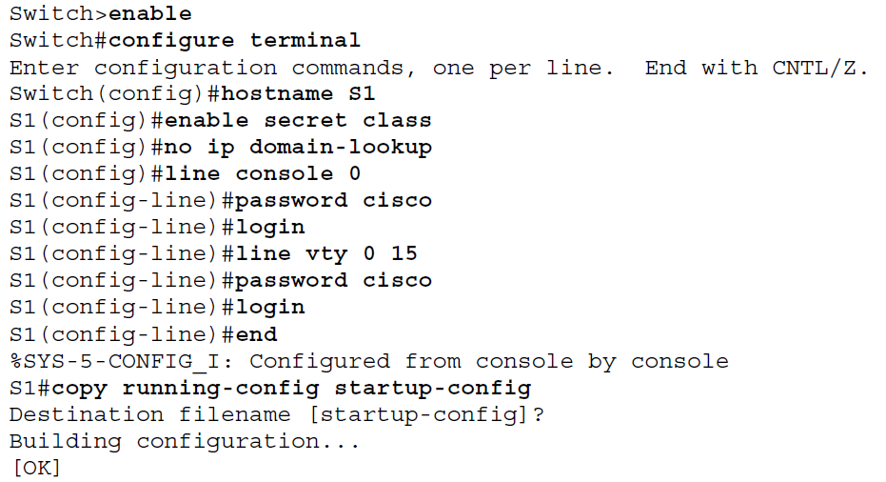Configure a password of cisco for vty connections.

Repeat the same commands on all 3 switches



✓

1. We will now disable all ports on the three by using the shutdown command.



Repeat the same commands on all 3 switches



✓

1. Re-enable the user ports on S2 in access mode. Refer to the topology diagram to determine which switch ports on S2 are activated for end-user device access. These three ports will be configured for access mode and enabled with the **no shutdown** command.





✓

1. Configure the Ethernet interfaces of PC1, PC2, and PC3 with the IP address, subnet mask, and gateway with the information below.

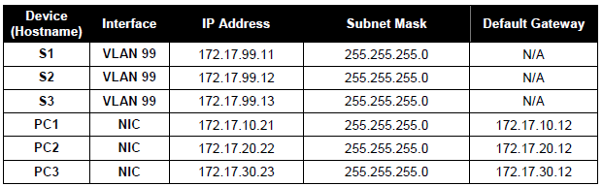



✓

1. Configure VTP on the three switches using the following table. Remember that VTP domain names and passwords are case-sensitive. The default operating mode is server.

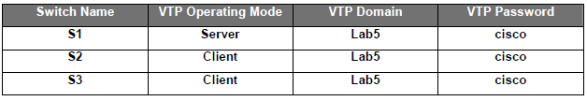

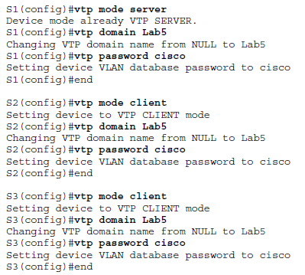

1. Configure Trunk Links and Native VLAN

Configure trunking ports and native VLAN. For each switch, configure ports Fa0/1 through Fa0/4 as trunking ports. Designate VLAN 99 as the native VLAN for these trunks. Use the interface range command in global configuration mode to simplify this task. Remember that these ports were disabled in a previous step and must be re-enabled using the no shutdown command.

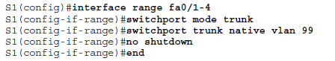

Repeat the same commands on all 3 switches

Depending on your topology, you may need to use different ports rather than just ports fa0/1-4.



✓

1. Configure the VTP server with VLANs.

VTP allows you to configure VLANs on the VTP server and have those VLANs populated to the VTP

clients in the domain. This ensures consistency in the VLAN configuration across the network.

Configure the following VLANS on the VTP server:

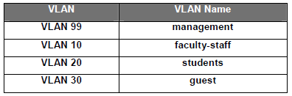

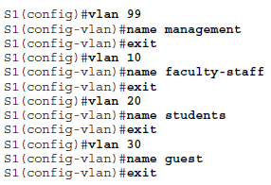

✓

1. Verify the VLANs.

Use the show vlan brief command on S2 and S3 to verify that all four VLANs have been distributed to the client switches.

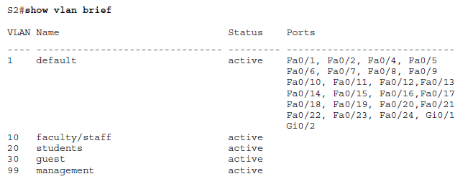

✓

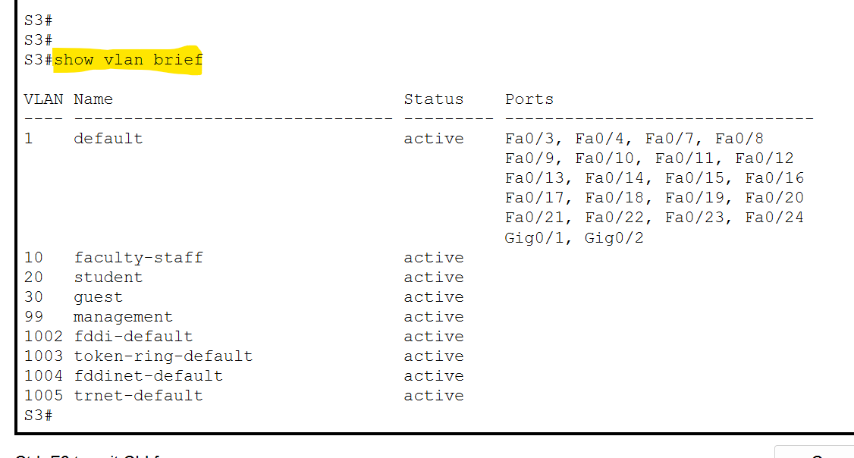

1. Configure the management interface address on all three switches

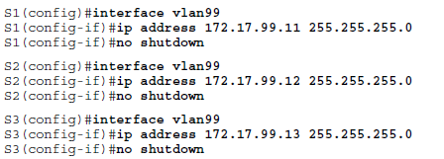



✓

Verify that the switches are correctly configured by pinging between them.

From S1, ping the management interface on S0 and S2. From S2, ping the management interface on S3.

Were the pings successful? ___________________________________________

If not, troubleshoot the switch configurations and try again.



✓

1. Assign switch ports to the VLANs.

Assign ports to VLANs on S2. Depending on the switch ports which have been assigned already, assign

a range of ports to each Vlan as show below i.e. assign a range of six ports to each Vlan.

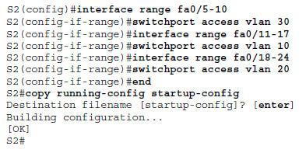



✓

1. **Examine the default configuration of 802.1D STP.**

On each switch, display the spanning tree table with the **show spanning-tree** command.

Note that there are five instances of the spanning tree on each switch.

The default STP configuration on Cisco switches is Per-VLAN Spanning Tree (PVST+), which creates a

separate spanning tree for each VLAN (VLAN 1 and any user-configured VLANs).



✓

Answer the following questions based on the output.

1. What is the bridge ID priority for switches S1, S2, and S3 on VLAN 99?
2. S1 _**32867**______
3. S2 _**32867**______
4. S3 _**32867**______
5. What is the bridge ID priority for S1 on VLANs 10, 20, 30, and 99?
6. VLAN 10 _**32778**____
7. VLAN 20_**32788**____
8. VLAN 30_**32798**_____
9. VLAN 99_**32867**_____
10. Which switch is the root for the VLAN 99 spanning tree? ___**S1**_____________

1. On VLAN 99, which spanning tree ports are in the blocking state on the root switch? ___**None**__________
2. On VLAN 99, which spanning tree ports are in the blocking state on the non-root switches?

____**On S3 – Fa0/2**_**&**_**On S2 – Fa0/2-4**__________________

1. How does STP elect the root switch? _**___Based on the bridge priority**_____________________
2. Since the bridge priorities are all the same, what else does the switch use to determine the root?

**Using MAC address**

________________________